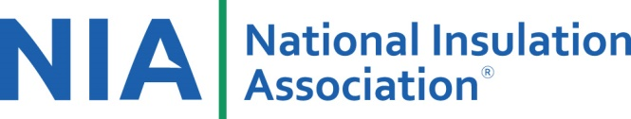
Benefits/Return on Investment of Attending NIA’s Meeting
NIA’s staff is happy to provide information that will help your company understand the benefits of attending NIA’s meetings and participating in committees. Highlights of NIA’s 63rd Annual Convention include:
- Over 20 hours of education and 10 hours of dedicated networking, including 3 breakfasts, 1 lunch, and 2 dinners.

- Technical presentations and committee forums featuring industry-specific speakers.
- New Wednesday–Friday schedule, which minimizing members’ time out of the office and allows attendees the option to stay in Orlando longer or head home to get back to their family or businesses sooner.
- Open meeting times to allow attendees the opportunity to schedule their own meetings while on-site to maximize their time.
Company Advantages
- The opportunity to meet new potential customers, vendors, and NIA leadership with over 10 hours dedicated to peer-to-peer networking.
- Learn more about how NIA can help your company and the insulation industry.
- Hear from your peers on a variety of topics that impact day-to-day operations and larger industry challenges during the Mechanical Insulation Industry Perspective Panel Discussion.
- NIA member companies who send more than 2 attendees to the Convention will receive an automatic $100 discount on third or additional registrants (spouses/guests are not eligible for this discount.).
Survey Results from the 2017 Convention
- 95% of attendees said that the overall session content and quality was excellent or good.
- 89% of attendees said that networking with new or potential customers was good or excellent.
- 71% of attendees said they made new business contacts.
- 93% of attendees said they will attend NIA’s 2018 Convention.

