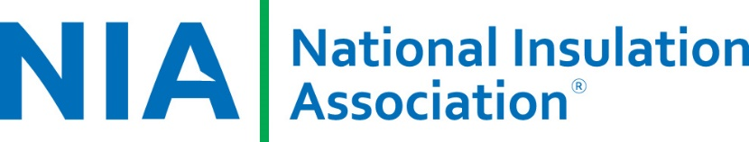

**LET’S MAKE IT HAPPEN CHALLENGE**

**YES**, I accept Dana’s challenge and will commit to the following between now and April 2020.

____ As a Manufacturer, I will add Certified Insulation Inspectors to our specifications.

____ I will attend the NIA Fall Summit (November 4-5, 2020) at MGM National Harbor, Maryland.

____ I will attend the NIA Annual Convention (April 15-17, 2020) at JW Marriott Camelback Inn, Scottsdale, AZ.

____ I will attend a Thermal Insulation Inspector Certification Course by the end of 2020.

____ I will attend an Insulation Energy Appraisal Certification Course by the end of 2020.

____ I will plan on participating in the 2020 Capitol Hill Fly In, May 19-20, 2020.

____ I will plan on participating in one of NIA’s webinars.

____ I will contact NIA about an *Insulation Outlook* article idea.

____ I am currently not a Foundation Contributor but will contribute this year.

____ I am currently not a NIA committee member but will join a committee this year.

____ I am currently not a member and plan to join NIA in 2020.

____ I will facilitate a Lunch & Learn with NIA and an end user/owner or engineering group.

_______________________________ ___________________________ _____________________________________

NAME COMPANY EMAIL AND PHONE

Thanks for taking the challenge! Email your completed form to [NIAinfo@insulation.org](mailto:NIAinfo@insulation.org).