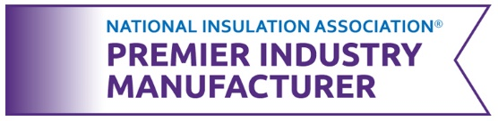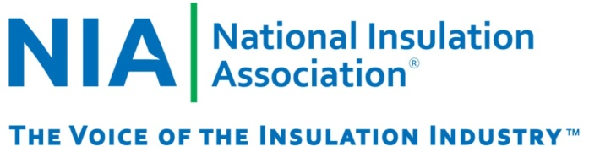

NIA’s Premier Industry Manufacturer Program

2024 Application

*A NIA Members-Only Program*

**NIA’s Premier Industry Manufacturer Program**Created by NIA’s Associate (Manufacturer) members exclusively for Associate members, NIA’s Premier Industry Manufacturer Program recognizes and distinguishes exemplary companies as industry advocates and leaders. Through this program, NIA’s Associate members demonstrate to their customers that they are recognized leaders.

This program has been developed to reward Associate members for their actions supporting NIA and the industry. NIA continues to develop the program to ensure it provides the most value to NIA’s Associate members and brings recognition from peers and clients.  
  
**Application Process and Eligibility**As a benefit of your membership with NIA there is no cost to participate in this program and NIA encourages all Associate member companies to apply.

* Applicants must be NIA Associate members in good standing for their application to be considered. (i.e., your company’s 2024 NIA membership dues must be paid in full, at the appropriate dues category, by the time your application is submitted). To check your company’s membership status, please email [*membership@insulation.org*](mailto:membership@insulation.org).
* The deadline to apply for the 2024 calendar year is **Friday, November 8, 2024.**
* Once an application is submitted, NIA will track the majority of the point opportunities from Jan. 1 of the application year and will combine this total to the Applicant Point-Tracking Form.
* Some activities will require the individual member company to complete a [Point Questionnaire](https://insulation.org/wp-content/uploads/2023/04/Final-Premier-Industry-Manufacturer-Program-2023-Member-Point-Tracking-Form.pdf). This form will outline all eligible activities, including their assigned point value, and must be completed and submitted to [*membership@insulation.org*](mailto:membership@insulation.org)by **Tuesday, December 31, 2024,** to receive points for these activities.
* Companies that reach a minimum of **175 points** throughout the 2024 calendar year will be recognized as **Premier Industry Manufacturers**. Program benefits include:
  + Recognition at NIA’s 69th Annual Convention, April 28–30, 2025, at the Hyatt Regency Scottsdale Resort & Spa at Gainey Ranch in Scottsdale, Arizona.
  + Companies will have access to the **Premier Industry Manufacturer** name designation and logo for the year they receive the designation. The logo can be added to marketing and promotional materials, email signatures, and the company’s website.
  + Companies that achieve the recognition will be promoted on NIA’s website and in marketing materials.
  + For a full list of program benefits, please visit [*www.insulation.org/membership/Premier_benefits*](http://www.insulation.org/membership/Premier_benefits/)*.*

**If your company can check “Yes” to any of the following,   
you are already on your way!**

* + NIA Membership in Good Standing (25 Points)
  + Membership in a Regional Association (3 Points per Group for Max 21 Points)
  + Contributing to the Foundation (5–20 Points)
  + Advertising & Sponsorship (5–45 Points)
  + Attending NIA Events (Max 52 Points)
  + Attending Training Classes (Max 50 Points)
  + Subscribing to NIA’s Education Center (20 Points)
  + View additional point opportunities at [*www.insulation.org/opportunities-to-earn-points*](http://www.insulation.org/opportunities-to-earn-points).

**Instructions**

Please complete this application and submit it no later than **Friday, November 8, 2024**, by emailing it to [*membership@insulation.org*](mailto:training@insulation.org)or by mailing it to the address below. Please be sure to assign a Recognition Program Contact on the form below. This individual will receive reminders and updates on the program.

National Insulation Association (NIA)

Attn: Rianna Gleeson

516 Herndon Parkway, Suite D

Herndon, VA 20170

Company Name: __________________________________________________________

Address: _________________________________________________________________

City: ______________________________ State: _____________ Zip Code: ____________

Primary NIA Contact: __________________________________________________________  
  
Phone: ______________________________ Email: _______________________________

Recognition Program Contact: ________________________________________________

Phone: ______________________________ Email: _______________________________

Signature: _________________________________ Date: __________________________

**Questions**If you have any questions regarding the application process or the Premier Industry Manufacturer Program, please contact Rianna Gleeson at [*membership@insulation.org*](mailto:training@insulation.org) or call 703-464-6422, ext. 113.