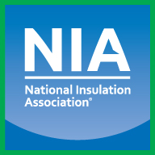
NIA’s Free Mobile Meeting App
(Available for iOS and Android devices)

Instructions for Downloading NIA’s Mobile Meeting App

- Visit the Apple App Store or Google Play Store on your phone. Search for the app using the key words “NIA Events” or scan one of the QR codes below to download the app.

Apple App Store Google Play Store How to Download
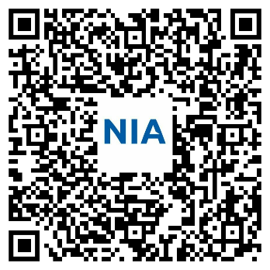
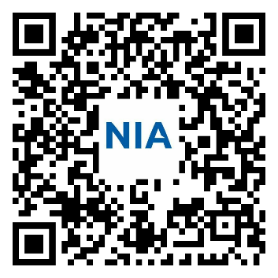
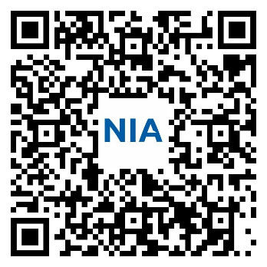

- Use the app to access the Convention schedule, attendee list, committee agendas, speaker bios and presentations, surveys, and much more!

If you have any questions about the Mobile Meeting App,
please visit NIA’s Registration Desk and a staff member will be happy to assist you.


Sponsored by:

